Great Plateau 100%
By Stompee, Futurelander
| Version 1.1

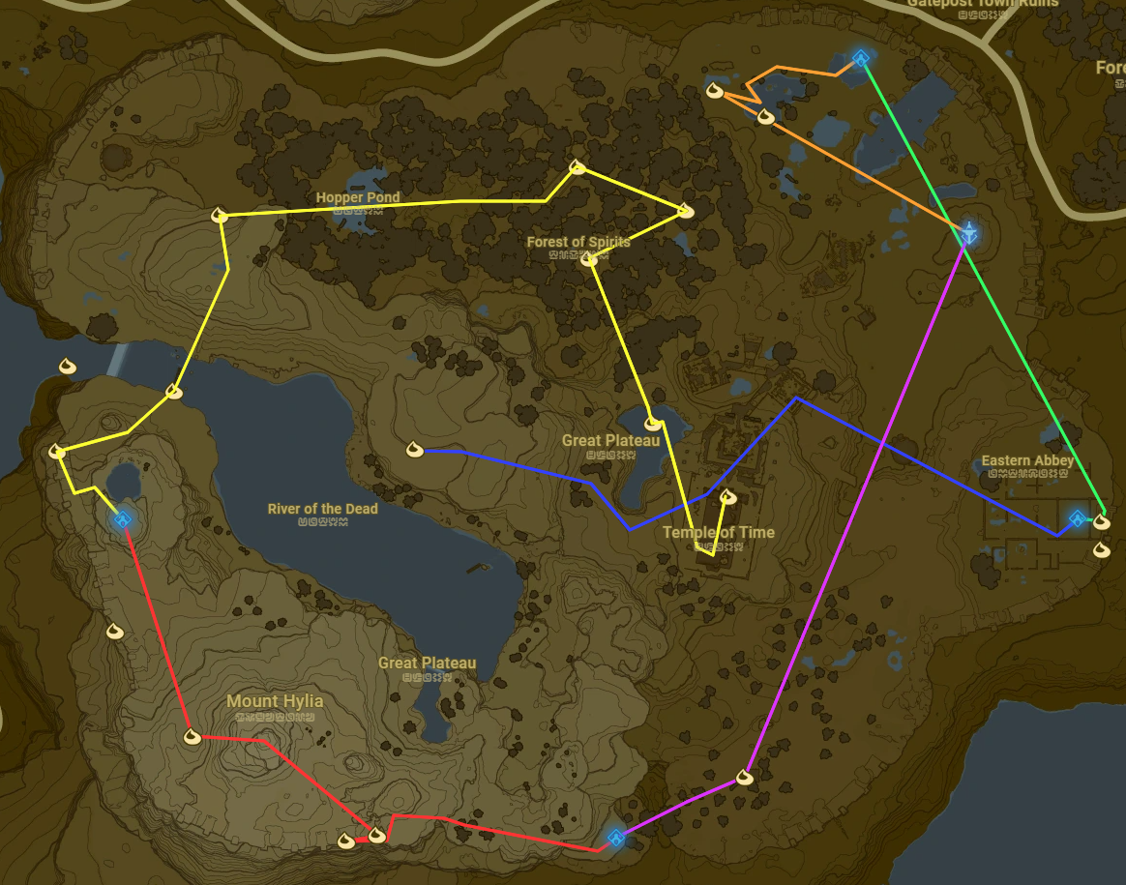
Blue, green, orange, purple, red, yellow

Key
Black Text - Required
Blue Text - Recommended
Orange Text - Optional
Red - DLC Exclusive

Information
Great Plateau 100% is a category in which you collect every accessible korok and armor piece, activate the tower, get a heart/stamina container, beat all the shrines, and defeat the stone talus, before ultimately ending the run by getting the paraglider. An important note about this category is that leaderboard runs are separated by “DLC” and “No DLC”, with DLC being the more popular variant of this run. The reason for this separation is because if you have the DLC installed, there is an extra armor piece on plateau.

Bombs
- Grab the Sheikah Slate
- Sprint northeast towards chest containing the Well-Worn Trousers
- Sprint left and snag the Old Shirt from the chest
- Sprint south and clip out of SOR
- Clip inbounds into the snow and head east towards the bokoblin camp
- Collect 6 Spicy peppers, a Pot Lid, a Wooden Spear, the meat cooking on the fire and 3 Hylian Shrooms
- Shield surf towards temple of time and activate the zelda cutscene
- Shield Clip into the window and grab the chest containing a Traveler’s Bow
- Break the first pot against the wall to the left and grab 5 arrows
- Perform the bow lift smuggle slide on a pot and slide to chest containing Hylian Trousers (you can also run there)
- Headshot the boko
- Perform BLSS on the barrel to the west and slide to DLC chest outside of the bombs shrine (slide straight to the shrine if no DLC)
- Open the chest containing the Nintendo Switch Shirt
- Shield clip into the shrine and enter the shrine
- Ragdoll fix and windbomb to the monk and finish the shrine

Magnesis
- To advance through the old man’s text optimally, first select the second option, then the first, the first again, and the second (2 1 1 2)
- Sprint east and climb the wall, heading towards the korok
- Bomb the metal door and pick up the rock to get the korok
- Climb back up the wall and Perform BLSS on a bomb, then slide to the magnesis shrine
- Break metal box for resources then shield clip into the shrine and enter the shrine
- Ragdoll fix and windbomb or run to monk chamber and finish the shrine

Tower
- Sprint west shield flip into the pond, and swim to land
- Run to bog, shield flip onto wooden platform, and grab the chest on the left containing fire arrows
- Use magnesis on the metal ball on the south end of the bog to get the korok
- Jump back to land during the cutscene and run west towards the rock
- Pick up the rock and get the korok
- Drop the rock and head to the front of the rock formation, perform BLSS on a bomb and slide to the tower
- Activate the tower
- Skip the cutscenes and jump off the tower
- Fall damage cancel before hitting the ground and activate the old man cutscene

Stasis
- Turn around after advancing through the old man’s text, and climb the tower until you reach the second platform
- Perform BLSS on a bomb and slide to the old man’s hut
- Climb the hut and get the korok
- Run off the hut, grab axe inside of hut, grab a Hylian Shroom and Pot Lid, then cook 2 spicy peppers
- Shield surf west and run to the first pine tree and remove ragdoll
- Climb to the top and spider windbomb the the stasis shrine
- Activate the pedestal and enter the shrine
- Windbomb or run to sledgehammer, grab it, then run to the monk chamber and finish the shrine

Cryonis
- Run southwest and boulder launch northwest (5 hits)
- Eat cold resistance food, remove ragdoll and climb up mountain and run past the rock korok
- Run to stone slab alongside the wall, stasis and hit it 2 times, then pick up the rock for the korok
- Run east back up the slope and pick up rock to get another korok
- Climb the wall and windbomb to the old man
- Talk to him and get the Warm Doublet (equip it if you aren't comfortable with your food)
- Slide down the mountain to the rock circle puzzle and get the korok while surfing towards cryo
- Keep surfing and climb the rock to cryo
- Activate the pedestal and enter the shrine
- Windbomb to monk and finish the shrine
Paraglider
- Mash through old man’s text and run northwest
- Shield flip FDC to wall, then shoot the ice block with 4 fire arrows and get the korok
- Jump off the wall to the east and fall damage cancel
- Shield surf to wooden bridge, remove ragdoll and get the korok
- Windbomb north, then shield surf towards cliff
- FDC to korok
- BLSS off the metal cubes to Talus
- Equip sledgehammer and defeat the talus
- Grab 3 Hylian Shrooms and sprint east towards hollow tree
- Get the flower chase korok in the tree
- Sprint east towards leaf pile under tree
- Strike the pile with your axe, pick up the rock, and get the korok
- Sprint southwest towards rock formation
- Climb to the top, pick up the rock, and get the korok
- Windbomb to lily korok, and jump in the pond to get it
- Swim to patch of land and Windbomb to the roof of the Temple of Time
- Jump down into the temple and pray to the angel statue
- Windbomb or climb to the roof
- Climb the spike and get the korok at the very top of the Temple
- Jump off and activate the old man cutscene, timing ends when you get the glider

